

**Hardhat Enterprises**

**Fortify Strategy and Questionnaire Team**

**Key Deliverable:** To research and strategize the volunteer onboarding and assessment process.

Tasks we aim to complete by semester-end:

1. Research and Create a contact process for volunteer cyber experts (ON HOLD - marketing team have covered this)
2. Create an induction form for volunteer cyber experts to initially fill out on the website
3. Create an assessment interview process for Fortify consultants to better understand/vet/approve or deny applicants
4. Create a full end-to-end Customer and Volunteer Process
5. Prototype a back-end dashboard for Fortify consultants to better visualize the experts and clients on hand

Table of Contents

**Induction Form for Website2**

Design Team Mockup4

**Fortify Assessment Interview Questions5**

General Questions5

STAR Questions5

Technical Questions6

**Fortify Customer Process8**

**Fortify Customer Process Flowchart10**

**Fortify Volunteer Process11**

**Fortify Volunteer Process Flowchart12**

**Fortify Back-End Dashboard Prototype14**

**Induction Form for Website**

**Aim:** Receive initial applicant details and preferences

* First Name
* Last Name
* Email
* Phone Number
* What is your current organizational level of expertise? (drop down)
  + Junior
  + Senior
  + Manager
  + Senior Manager
  + Executive
* What is your current experience level within the technology field? (slider)
  + 0 – 1 Years
  + 1 – 5 Years
  + 5 – 10 Years
  + 10 – 25 Years
  + 25+ Years
* Please preference the areas in which you are most comfortable providing strategic and/or technical advice in:

1. Cloud
2. Network Security
3. Security Infrastructure
4. Cyber Security Policy Making
5. Cyber Security Strategy and Transformation (Governance, Risk and Compliance)
6. Cyber Security Maturity Assessment
7. Penetration Testing (Blue Team)
8. Penetration Testing (Red Team)
9. Identity and Access Management
10. DevOps and Secure Software Development
11. Incident Response
12. Forensic Discovery and Analysis
13. Security Operations Center
14. Emerging Technologies (AI, Blockchain, Metaverse, Space Technology?)
15. Other:____________________

* Please briefly describe your experience in the area(s) ticked above:

_______________________

* Please briefly describe any preferences of client and/or job type?

_______________________

* How many volunteer hours would you like to commit to a project?
  + 3 – 5 Hours per week
  + 5 – 10 Hours per week
  + 10 – 20 Hours per week
  + 20+ Hours per week
  + Other:
* Location
  + NSW
  + VIC
  + QLD
  + WA
  + SA
  + TAS
  + ACT
  + NT
* How did you find out about the organization?
  + Friends
  + Online search
  + Direct Mail
  + Business colleague
  + Other:___________________
* Please detail any further notes or questions:

_______________________

* How would you like to be contacted in the future:
  + Phone
  + Email

**SUBMIT BUTTON**

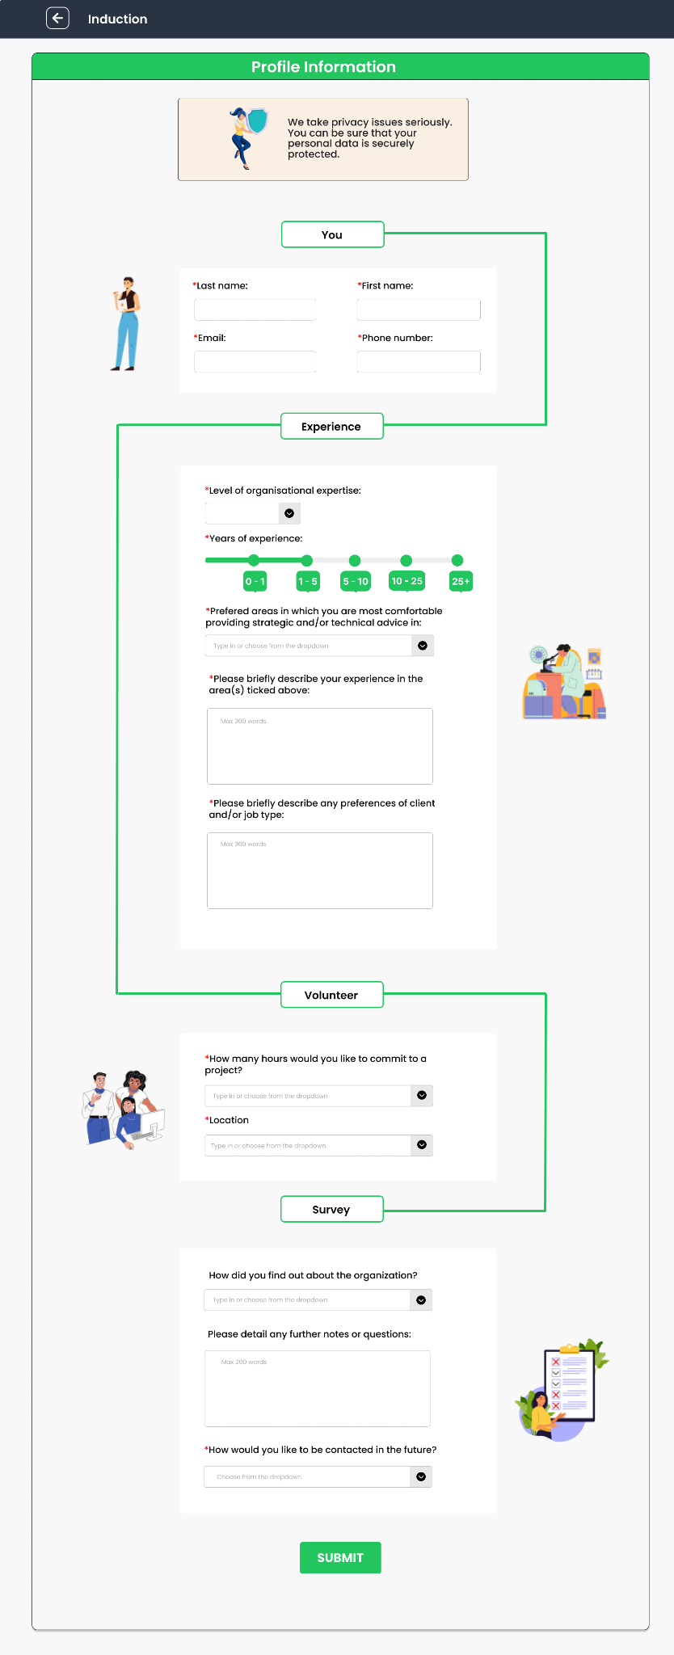**Induction Form for Website - Design Team Mockup**

**Fortify Assessment Interview Questions**

**Aim:** Gauge applicant skills, prove applicant identity, properly categorize applicant profile.

## **General Questions**

To start the interview and gauge the applicant’s motivation, work ethic, interests, and overall behaviour in a professional environment, we first ask some general personal questions:

- Tell me about yourself and why you applied?

o This will generally get the applicant to give personal information such as name, age, and hometown which can be cross examined with the initial applicant’s application – this is to help prove identity.

- List three of your top strengths

o Communication, resilience and patience, critical thinking, problem solving, decision making.

- What is a weakness of yours and how would you go about overcoming it?

o Focus less on the weakness and positive implementation of ways to overcome it.

- Do you prefer to work in a team or by yourself?

o Ultimately, explain both are just as important as each other but having a preference is ok.

- What is an accomplishment you are proud of in relation to the industry?

o An accomplishment related to the role the applicant applied for is deal.

- What do you know of our company and our mission?

o Applicant should state our company mission and objectives and understand why this program was created.

## **STAR Method Questions**

STAR questions inquire about situations and problems faced in the workplace. This helps the interviewer understand how the applicant handles different situations.

- Have you ever faced conflict with a client? How did you resolve the situation?

o Look for communication between parties to resolve issue, look for escalation where necessary to achieve resolution.

- Have you ever had to work under a deadline? How did you navigate this?

o Prioritization, working from a list, time management, communication.

- Has a client ever asked for the “impossible”? how did you explain and communicate this to them?

o Suggestions on different approaches to reach the same/ similar end goal, respectfulness, patience, and understanding toward the client.

- Give an example of a time you made a mistake at work, how did you fix or resolve this issue?

o Honesty, responsibility, communication, and professionalism to admit there was a mistake that needs to be fixed. Incident should be reported/ recorded in a report.

- How do you adapt to sudden change in the workplace?

o Look for adaptability, willingness to learn, cooperation, resilience.

## **Technical Questions**

These questions are designed to test the knowledge of the applicant in technical situations.

- What certifications do you hold at this current time?

o List of current and relevant certifications which should line up the applicant’s application.

- What are some tools you use on a daily/ weekly basis? – these could be development, automated build, programing, or source control tools.

o List of tools and why these tools are used.

- Give an example where you have applied your technical knowledge in a practical way.

o An example to show that the applicant can put their knowledge to practical use.

- Can you explain the CIA triad model?

o Confidentiality, Integrity, Availability – these should be clearly listed and defined.

- What is a firewall and why is it used?

o Basic definition of a firewall, its uses, and its importance.

- Can you explain the difference between vulnerability testing and penetration testing to a client with no knowledge of either?

o Clear definition of both testing techniques, clear explanation of both, using both simple and technical terms – interviewer to question technical terms.

- Can you list some common cyber-attacks that would occur in small to medium businesses?

o Malware, phishing, password attacks, ddos, man in the middle, drive-by downloads, malvertising, rogue software

- If presented with one of the previously mentioned attacks, could you provide details on how to prevent such an attack from happening in the future?

o Prevention techniques of one of the above common attacks

eg: brute force attack: implementation of a password policy – password length, password complexity, limited login attempts.

**Fortify Customer Process**

**Aim:** Demonstrate the end-to-end process we envision customers completing to be able to get full functionality of the Fortify product and be matched with a suitable volunteer.

1. Customer navigates to initial questionnaire page:
2. Option of immediate help button or fill in questionnaire
   1. Questionnaire to include contact details and other core information
3. A thank you message via email and invite them to fill in additional questions (typically Yes/No) via a link - this link should lead to a page with questions.
4. Customers may then choose to fill in some additional questions via this email link or we can arrange a phone call if they would prefer this option.
5. The company reviews and match with the volunteers

**Initial Questionnaire**

|  |  |  |  |  |
| --- | --- | --- | --- | --- |
| Response    Category | Never heard of this | Aware but not implemented | Partially implemented | Fully Implemented |
| Anti-virus / Anti-malware software |  |  |  | Shape |
| Operating System Updates |  |  |  | Shape |
| Software Program Updates |  |  |  | Shape |
| Multi-Factor Authentication (or MFA)  Often this is a security code sent to your mobile phone when logging in to a website for example. |  | Shape |  |  |
| Data Backups |  | Shape |  |  |
| Cyber Security Awareness Training |  | Shape |  |  |
| Restricted Administrator Accounts on computers and laptops | Shape |  |  |  |

**Sample Email**

Hi there Beatrice,

You found us! Thank you for starting your application with Fortify. We’re delighted to have you.

You’re receiving this message because our application process has a second step. This will help us work more closely with you and assist in areas where you need it most.

If you’d prefer to talk to us instead, no problem, give us a call.

Please use the questionnaire below to tell us a little more about your organization

**sample link:<https://www.thesprucepets.com/why-cats-are-better-than-dogs-554880>**

|  |  |
| --- | --- |
| Which one of the following statements best describes your organization? | * My organization is well prepared to respond to a cyber-attack.    My organization is somewhat prepared to respond to a cyber-attack. * My organization is slightly prepared to respond to a cyber-attack. * My organization is not at all prepared to respond to a cyber-attack. |
| How many people work at your organization and across how many sites? |  |
| Which one of the following statements best describes you? | * I am a cyber/IT professional who works in the organization's cyber/IT team.      * I am the only cyber/IT professional who works in the organization.      * I am not a cyber/IT professional but am technologically savvy.      * I am not a cyber/IT professional and am not technologically savvy. |
| What sort of devices are used in your organization? (List as many as you can think of) | i.e.. mobile phones, tablets, laptops, desktops, IoT, printers |

*This will also be a good opportunity for marketing to throw in ‘Where did you hear us from? LinkedIn, colleagues, Facebook, others

**Fortify Customer Process Flowchart**

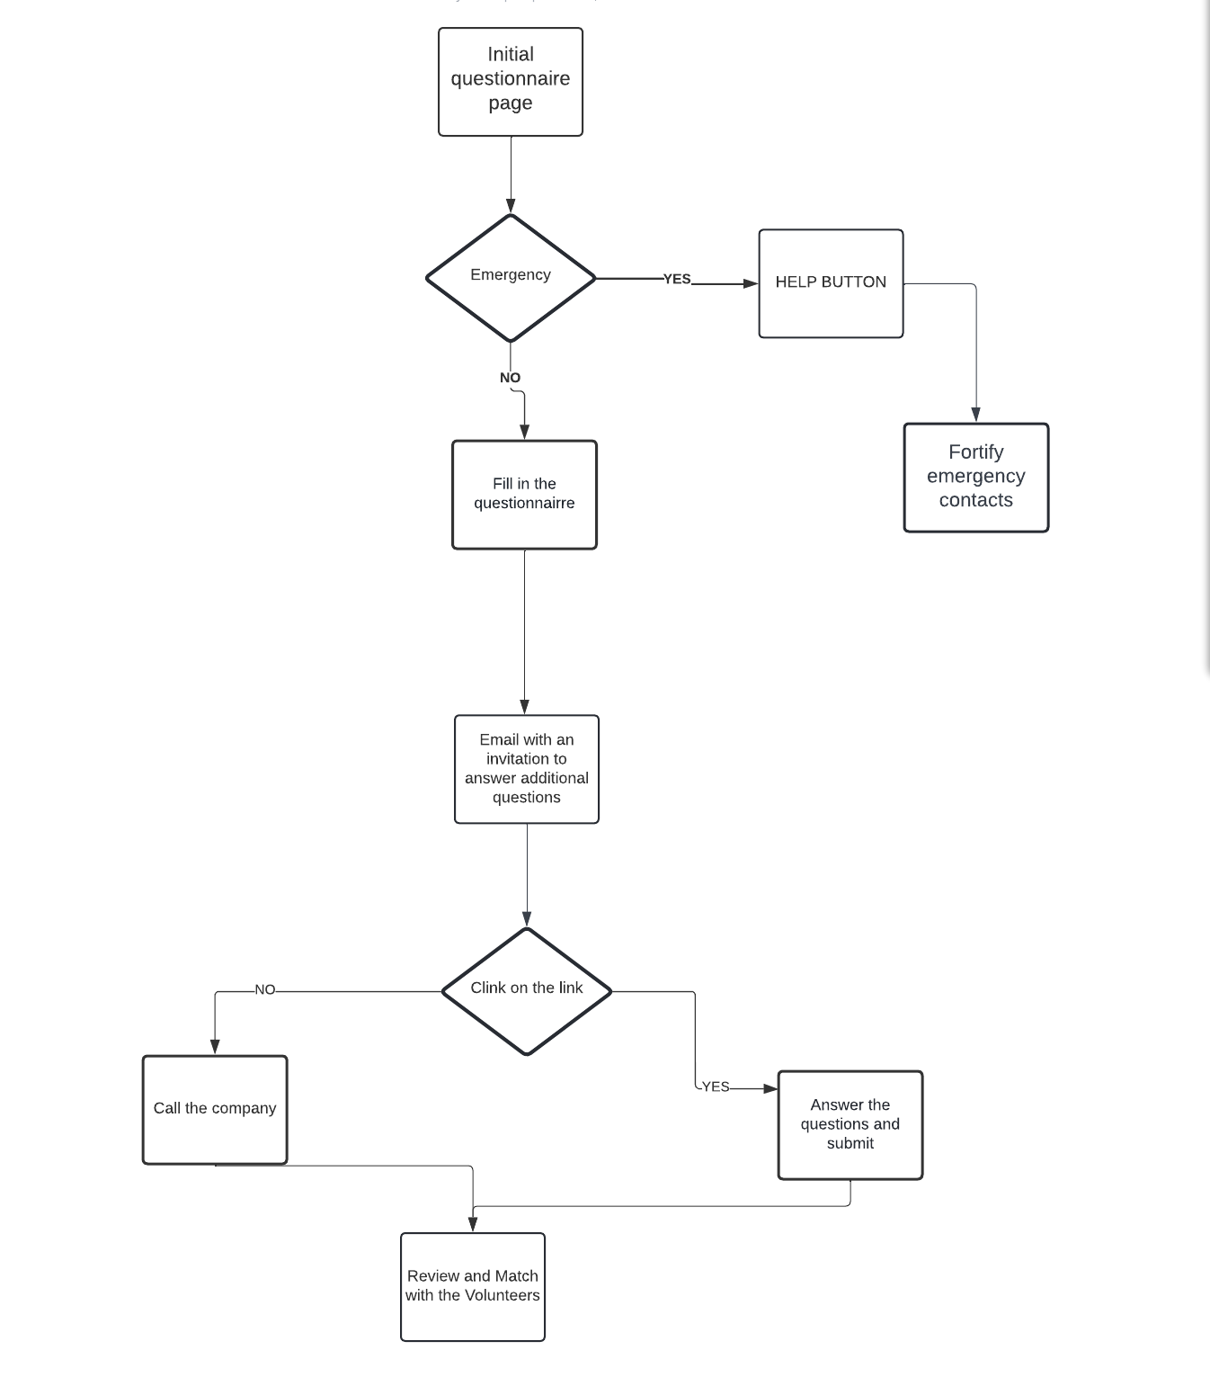

**Fortify Volunteer Process**

**Aim:** Demonstrate the full end-to-end process a Fortify Volunteer will complete to create a profile and be matched by Fortify Consultants to suitable customers

1. Volunteer navigates to the induction page.
2. Volunteer submits completed application.
3. Fortify Consultant reviews application.
4. Decision is made whether the applicant is accepted for denied for next stage.
   1. If yes, move to the next step.
   2. If no, applicant receives a rejection email.
5. Successful applicants will be interview by Fortify Consultants with assessment interview questions
   1. Zoom or Face to Face
6. Upon review, Applicant will be accepted or declined.
   1. If yes, move to the next step.
   2. If no, applicant receives a rejection email.
7. Applicant is rated using rating matrix by Fortify Consultants.
8. Applicant is offered employment.
   1. Employment accepted, move to the next step.
   2. Employment denied, application terminated.
9. Applicant has professional profile created and added to Fortify Website
10. Applicant becomes a formal volunteer and conducts Fortify standard work.

**Volunteer process once job is assigned:**

1. Contact is made between customer and volunteer
2. Volunteer completes work to best of their ability

* If problem arises, contact customer
* Contact fortify

1. Once work is complete, customer can submit a form saying the work was completed
2. Possible feedback form included for both parties, rating volunteer and customer
3. Ratings and possible problems can be detailed on our end, possibly on dashboard
4. Self reflection on job using job form

**Volunteer Escalation process:**

1. Problem/gap in knowledge occurs
2. Inform problem to Fortify (For example, marking project with red flag)
3. Find out what is causing the issue and analyze potential impact (For example, delays or cost overrun)
4. Alternative options for a resolution are considered, possibly from other volunteers
5. The possible solutions are presented to client
6. Potential impacts are also detailed to the client
7. Results of complications are documented into a form to be attached to the job sheet

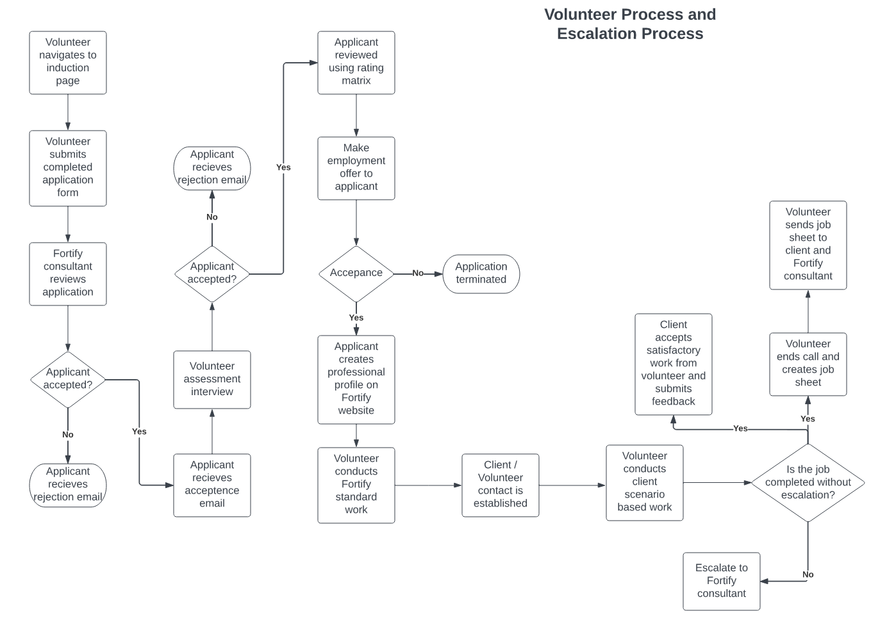

**Example of post-job completion form for Volunteers**

**Back-end Dashboard Prototype (Liaise with Design and or Database Team)**

**Aim:** To provide Fortify Consultants with data required to make further applicant and client decisions and matchmaking.

**Key Features:**

* Geography
* Cyber sectors (Number of volunteers)
* Number of Applicants to be reviewed
* Average star rating of volunteers
* Number of Successful Projects Completed YoY (from volunteers)

This dashboard is a **prototype** of what we have in mind for Fortify Consultants to be able to utilize this data for further applicant and client decision matchmaking. This will likely require further collaboration in coming semesters from the Database team (and possibly the Design team) as they are developing the back end and should have access to this data from various sources.

